Management Engineering Surgery Projects Report
Case Study, San Francisco General Hospital

February, 2009

David Belson, Ph.D.

University of Southern California

Work funded by a grant from the California HealthCare Foundation, 08-1170, to stimulate the use of management engineering in surgery in California Safety Net Hospitals.

Table of Contents

I. Summary 2
II. Background 2
A. Project Selection 2
B. Methodology 3
C. The Issues 4
III. Conclusions 6
IV. San Francisco General Hospital 8
A. Hospital Background 8
B. Findings & recommendations 13
C. Data & Results 18
V. Appendix 25
A. Proposal Evaluation Matrix 25
B. Project Startup Checklist 25
C. Hospital Data 26

Summary

Inefficiencies in the delivery of care limit the capacity of health care providers to serve patients, impeding access to care. The goal of this project was to achieve significant improvements in surgery at California safety net and critical access hospitals though development and adoption of best practices for management engineering.

Our team of faculty and staff from the USC Viterbi School of Engineering began three patient flow improvement projects at three California safety net hospitals in October 2008. These hospitals were selected based on proposals submitted to the California Healthcare Foundation, the project sponsor. Each hospital expressed a desire to increase throughput and eliminate bottlenecks. The three hospitals qualified as safety net hospitals but they differed in size, residency programs and ownership.

They all followed a similar patient flow pattern in surgery, beginning with registration and ending with recovery. The management engineering team sought to improve overall throughput by increasing the efficiency at each step, eliminating waste, reducing bottlenecks and better coordinating the movement of patients between steps.

The projects began with senior management meetings at each hospital and group meetings with nearly all of the surgery staff. Data were collected regarding patient flow. We analyzed the surgery data for recent months including times of patient movement, types of surgery, advance schedules and mix of patient types. The hospitals provided us with digital records of daily surgeries. These revealed delays and under utilized resources. The engineering team observed the daily surgery flow and interviewed many of the surgeons, anesthesiologists and nurses. This direct surgery observations and later flowcharting and analysis proved to be particularly helpful in developing ideas for change.

This report draft includes only the material of San Francisco General Hospital, not the other two studied.

Background

These projects follow three projects done earlier in radiology and surgery departments at other California safety net hospitals. The results of the radiology work are described in a California HealthCare Foundation Issue brief. (Available at http://www.chcf.org/topics/view.cfm?itemID=133532 ) The goal was to achieve significant improvements in care delivery at California safety net and critical access hospitals and demonstrate the usefulness of management engineering. By so doing, hospitals would be encouraged to implement their own ongoing management engineering function and process improvements.

Project Selection

A team of faculty and staff from the USC Viterbi School of Engineering began patient flow improvement projects at three California safety net hospitals (Valley Presbyterian Hospital, St. Francis Hospital and San Francisco General Hospital) in September 2008. These hospitals were selected based on proposals responding to a request for proposals (RFP) issued in July 2008 by the California Healthcare Foundation, the project sponsor. The hospitals were evaluated on a weighted multi attribute basis. See Appendix A.

Each selected hospital expressed a desire to increase throughput and eliminate bottlenecks within surgical departments, and to work with the USC team to implement change. Though all three hospitals qualified as safety net hospitals, they differed in size, residency programs and ownership (Table 1).

In order to receive the grant based management engineering service the hospitals had to agree to certain policies, such as making available relevant operating data for use in this report. Each project began with a checklist verifying the terms of the agreement and initial steps. (See Appendix B)

The three hospitals followed a similar patient flow pattern in surgery, as shown in Figure 1, beginning with admission and ending with recovery.

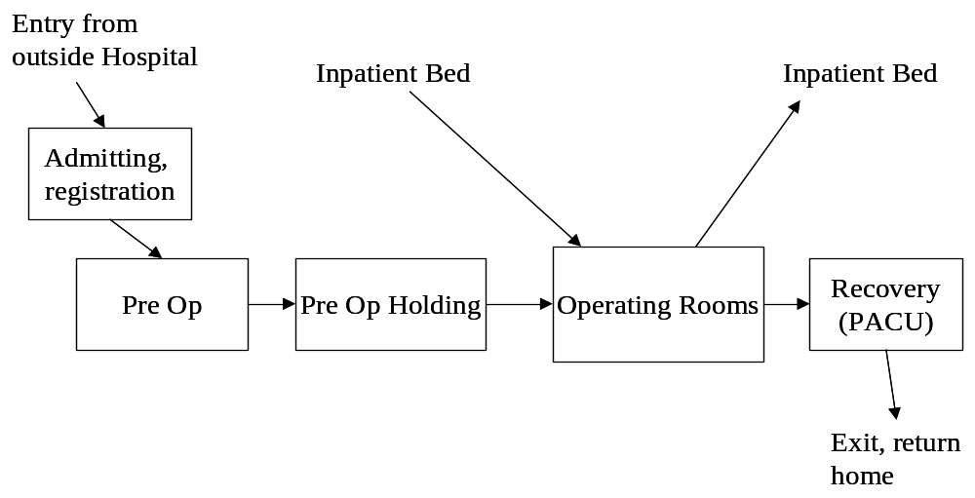
Figure 1. Typical Overall Surgery Patient Flow

Methodology

Our methodology requires close collaboration with all levels of staff, combined with careful observation and analysis of system performance. The projects began with senior management meetings at each hospital and group meetings with nearly all of the surgery staff. anesthesiologists.

Each project involved a series of necessary tasks. The challenges within each step were remarkably similar among the three hospitals. The management engineering team conducted the initial individual steps but the hospital’s staff increasingly led the later stages. (See Figure 2.)

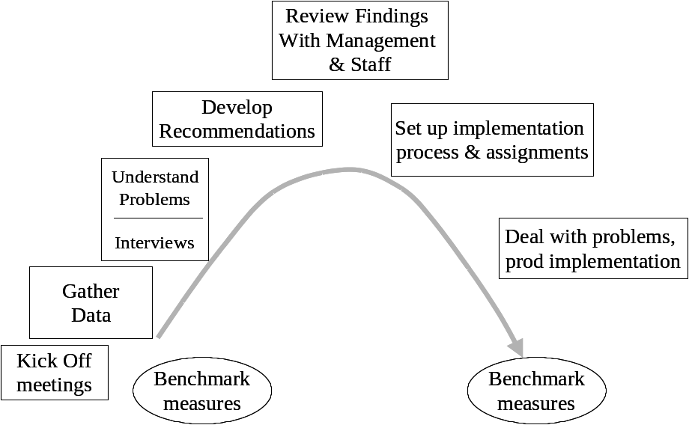

Figure 2. Sequence of tasks for the management engineering projects
Measurement: An important resource in management engineering is to have an accurate measure of the patient flow. We primarily focused on room turnaround time (TOT), at the request of the hospital, but also recognized other metrics as important such as room utilization, schedule accuracy and delays.

The Issues

Efficient utilization of surgery resources involves timely execution of a series of steps. Delays constitute waste, which results in idle time for patients, staff and facilities. More importantly, it reduces the capacity of the hospital – fewer patients can be seen and there is a longer wait for a surgery appointment with adverse clinical effects.

The basic sequence of time related to operating room turnover for all patient types is shown below.

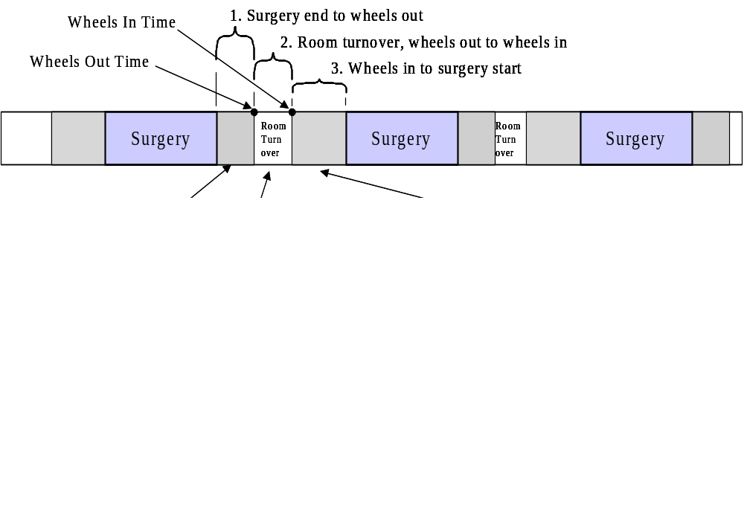
Figure 4 Room Turnover Steps

Each of these steps depends on a number of events; much of the effort in this project has been directed at reducing bottlenecks that prevent these events from occurring when needed.

Improving patient flow can be measured a number of ways. We found the following measures of effectiveness. These metrics could be incorporated into a surgery “report card” that would be useful to manage the area.

Useful metrics, and typical ways to measure them:

- Turnover time (TOT) - time between patient leaves OR (wheels out) until next patient enters (wheels in) and related times (See Figure 2.) Several other “turnovers” can also be computed which may be helpful in managing patient flow:
  - Surgeon turnover time, time between surgeries for the surgeon, close to next cut. The surgeon’s next surgery may be in a different operating room than the previous case.
  - Patient exit time, time from surgery end (close) to wheel out. This measures the promptness with which the staff completes its work
  - Patient prep time, wheel in to surgery start (cut). This includes time for anesthesiology and time for nursing to get the patient and paperwork ready
- Room utilization - % of available time rooms are occupied by patients including average turnover time. Turnover time is included because it is time that is not available for another case. An accurate metric would be based on number of rooms that were staffed, which may change throughout the day. A hospital may have more rooms equipped and ready for surgery but measuring utilization of staffed rooms is more important.
- Block time utilization. That is the percent that a block assigned to a service, such as orthopedics, is used. Block utilization is calculated to see if the block assigned to a specialty should be changed. Low utilization could mean that the time reserved for one service could be better used by another service. However, our management engineering efficiency study was more concerned about how well the rooms are used in total rather than by block because the block assignment decisions may be result of financial or educational requirements rather than patient flow.
- Schedule accuracy - degree to which scheduled patients’ surgery occurs as planned in advance. This can be measured as % of surgeries that start within 15 minutes of scheduled time in the scheduled room, or % of the time a case starts as planned in whatever room it occurs.
- Schedule case durations- a useful metric is the degree to which the scheduled elapsed time for each equals the actual elapsed time for each case. A surgeon may request an hour for a case when they typically use two hours to do a certain type of case. The hospital has historical averages, by surgeon and type of case, so that they are able to determine when requested times are inaccurate and can therefore prevent scheduling problems from occurring.
- First case start on time - % of the time the first case of the day in a room starts within 15 minutes of scheduled time. This is important because if the first case is delayed then subsequent cases will also likely be delayed. Some hospitals have found it useful to take an even more narrow view, a delay of 5 minutes or less being considered a late start.
- Delay frequency - % of surgeries where the start (wheels in) is delayed due to various causes, frequency of each cause is measured and these causes are sorted by relative frequency. Information systems for surgery often can capture this frequency data. This measure seems problematic, however, because some computer systems record only one cause, although multiple causes may have occurred. Also, the people reporting the cause of the delay may minimize their own role in the delay problem.
- Backlog or wait time for an available appointment – access to surgery is a key objective of management engineering. The wait is a function of the specialty for various types of cases as well as the severity of each individual case. It is difficult to accurately measure the backlog since providers often do not have consistent records of what cases are waiting an appointment. Also, wait times are affected by criticality, case type and availability of resources. Thus, this metric is rarely tracked except in terms of complaints from patients and physicians.

Conclusions

A management engineer looking at the processes with “fresh eyes” can improve patient flow and efficiency in surgery. Often a hospital’s staff has done its work the same way for many years without considering how a better flow could be designed.

Most of the recommendations, perhaps with some modifications, may be applicable to many safety net hospitals. We expect that the surgery function in all hospitals will benefit from similar management engineering projects and similar recommendations may be applicable elsewhere.

This draft report includes materials only on San Francisco General Hospital. A final version will include six hospitals and will be circulated to all.

San Francisco General Hospital

Hospital Background

San Francisco General Hospital Medical Center (SFG) is an acute care hospital owned and operated by the City and County of San Francisco. SFG provides a full set of inpatient, outpatient, emergency, skilled nursing, diagnostic, mental health, and rehabilitation services for adults and children. It operates the only Trauma Center (Level 1) for 1.5 million residents of San Francisco and northern San Mateo County.

Surgery Area Description

In terms of surgery, SFG offers a complete set of specialties and is a teaching hospital for the University of California at San Francisco Medical School. There are 10 operating rooms.


Figure IV-1 . San Francisco General Hospital Medical Center

The main surgery area’s operating rooms are located on the 3rd floor of the main hospital building as are registration, pre-op and recovery beds. Also on the 3rd floor are nursing and physician offices related to surgery.

A control desk which monitors the flow of work throughout the day is centrally located and is near a white board where the Charge Nurse of the ORs is located as well as the person doing advance scheduling of the operating rooms. See Figure IV-2.

Surgical admitting is done in a small office on the third floor near but outside the surgery area. The surgery area is security controlled so that visitor and family member traffic is eliminated.

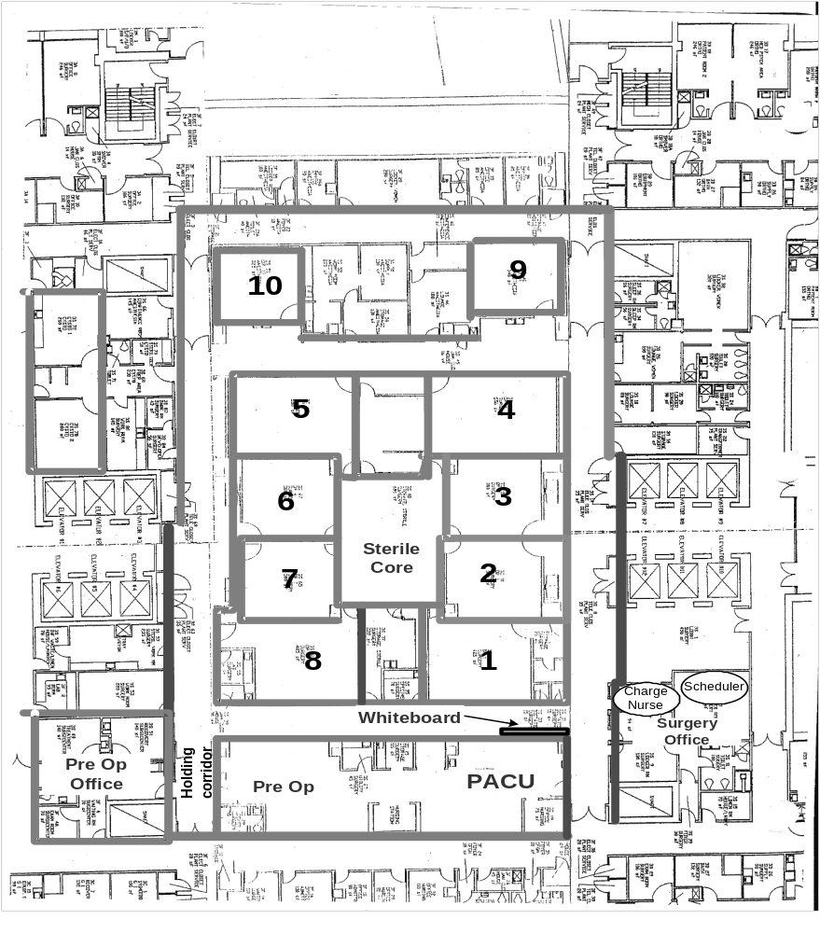
Figure IV-2. Physical layout of the surgical area at SFG

Regarding the movement of patients, see Figure IV-3, the typical path is relatively straightforward. Eight of the 10 operating rooms are arranged in the center of the layout around a sterile core, used for storage. The movement of supplies is also straightforward with most coming from a basement central sterile processing area and held in the sterile core directly accessible to most, but not all, of the operating rooms. Two ORs are outside of that central loop and although still connected to the general surgery area by the hallway, they do not have immediate access to the sterile core.

Outpatients start their day at registration on the third floor, which is located immediately outside of the secure surgery area but nearby the pre-operative area or so-called surgi-center area. At the registration desk the patients are given ID wristbands. Once the paperwork is completed the paperwork is brought into the Pre-Op office, located within the restricted access surgery area. The patients are then called into the Pre-Op holding area by nurses and are taken through all pre-operative steps, from changing clothes to medication checks, interviews and completing surgery consent forms in Pre-op holding. The patient goes directly from there to an OR. At the start of the day, the beds in the surgi-center are empty so the first set of patients is held in those beds. As the recovery area fills up during the day with recovering patients, the pre op holding patients are often in gurneys in the corridor near the pre op area. Once the pre op patient is ready for surgery, paperwork and a “ready” card is alongside the patient bed.

When surgery is completed the patient is brought from the OR to recovery, or PACU (post anesthesia care unit) also called surgi-center at SFG. Recovery is located in the surgi-center area where the patient was before surgery. In PACU the patient is brought completely out of anesthesia, outpatients are sent home from there, while inpatients are sent back to their floor when they are deemed fit.

The surgery area’s white board serves several purposes. It shows staff where they are assigned as well as the status of upcoming cases, such as whether they are in the pre op area, late to arrive or prepared and ready for the OR. Se Figure IV-4.

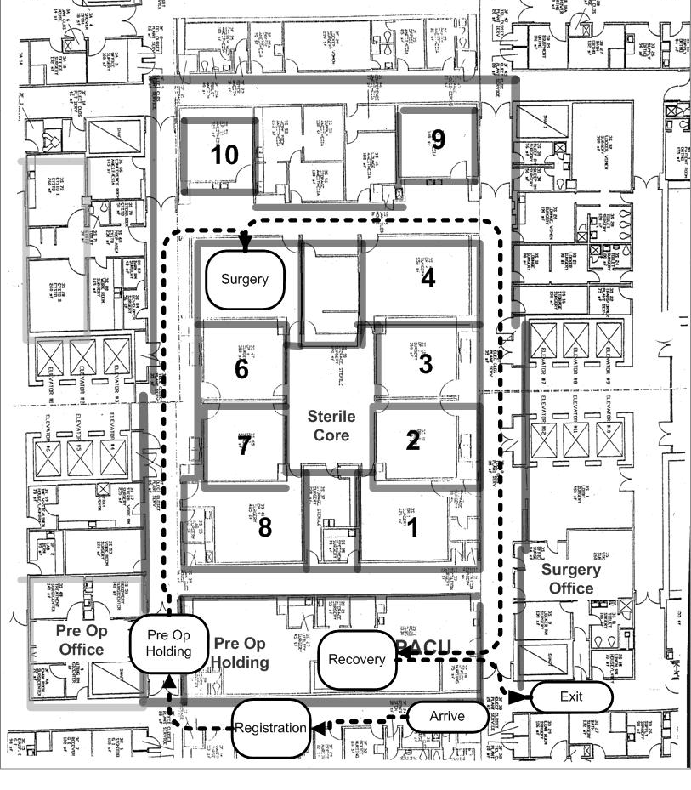
Figure IV-3. Patient flow the surgical area at SFG

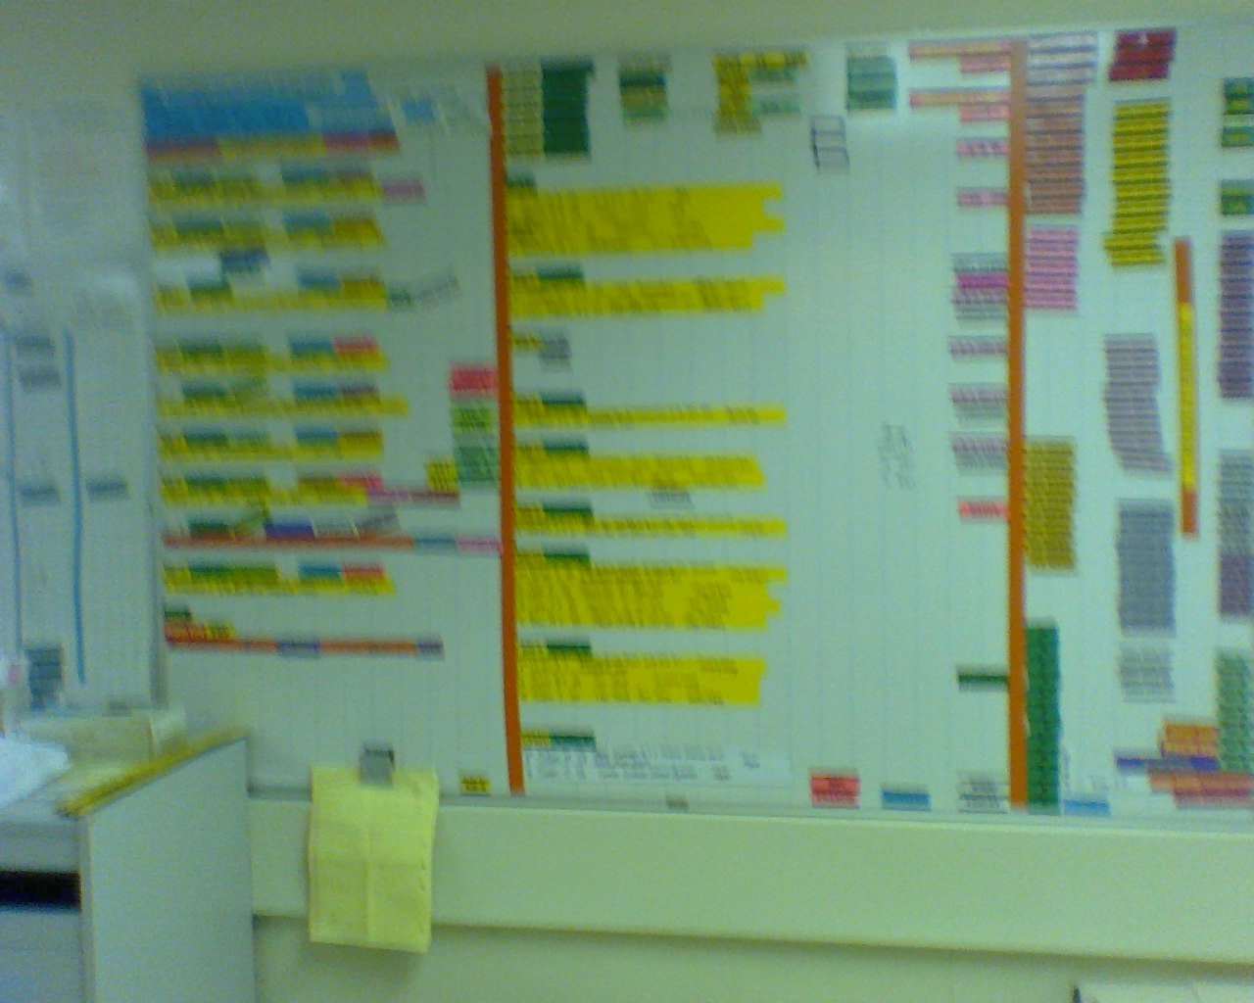

Figure IV-4. Whiteboard

In the operating room the surgery resident, anesthesiology resident and nursing prepare the patient for intubation and monitor the patient throughout the procedure. Attending anesthesiologists are the advisors to resident anesthesiologists. Each attending is assigned to two operating rooms each day and may provide break time for the residents. When the resident surgeon arrives at the OR, they start positioning and draping the patient and await the resident to begin the procedure. After closure and after the patient is wheeled out, surgical tech, scrub nurse and perhaps the circulating nurse gathers materials for disposal or recycling. The room is cleaned by a housekeeping team which consists of about 5 people with generally 2 or 3 housekeeping staff available during the daytime shift.
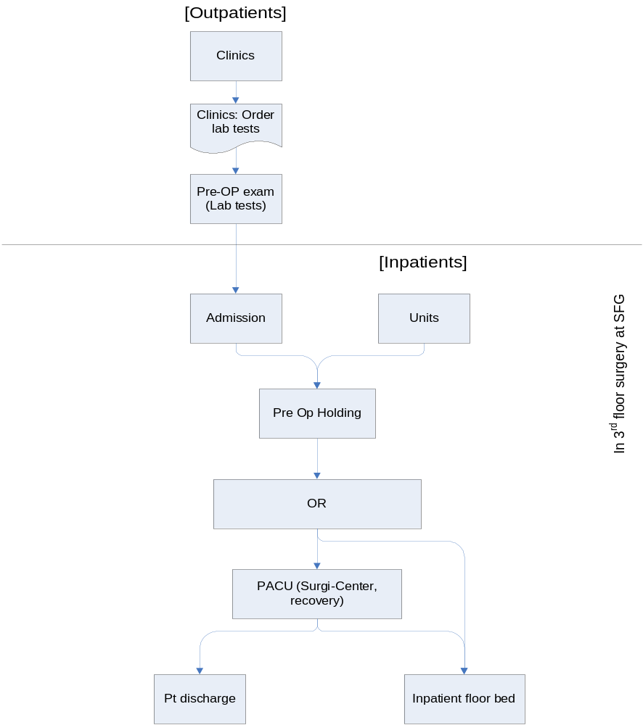
Figure IV-5 Staff Movement

Findings & recommendations

We observed patient flow in surgery over several weeks, interviewed staff, gathered statistical data and participated in group meetings and discussions. Through this data gathering and subsequent analysis we identified various bottlenecks and problems. All these issues we discussed with various hospital staff and management.

We determined the probable existence of the following patient flow related problems at SFG. These are listed in rough order of importance.

- General pace, mind set, regarding need to speed turnover time and increase throughput. A number of people in the department said that there seemed to be a lack of incentives, culture or training which led to a relatively slow pace of patient flow. This was said to be a cause of poor room turnover time and other metrics. We did not observe enough cases to be certain this was true. It probably varies by individual as well as professional role. Moreover, since we were quite obvious outsiders it was possible that the pace quickened when we were observing patient flow in the surgery area. Never the less, the turnover time metric was relatively high and it would appear that the pace of work contributed to this relatively long room turnover time and the results for other metrics.
- Operating room turnover time, room utilization and first case starts do not compare well to benchmarks. An average room turnover time of 55 minutes is high compared to such values at similar hospitals. This amount of time wastes opportunities for additional cases each day. Room utilization of about 70% during the day shift is relatively low. Additional cases could be performed were the utilization greater. Many such hospitals achieve 80 to 85% utilization during the daytime shift. These opportunities total considerable value. The hospital estimated surgery minutes at $64. A reduction of average turnover time of just ten minutes, which appears quite feasible, represents a potential value of over $2 million per year.
- Duplication of effort during Pre Op delays turnover time and first case start times. Unnecessary redundancies should be identified and eliminated. Some tasks in patient interviewing appear to be duplicated between the nursing staff and the surgeons and anesthesiologists. Although some duplication is needed for legal or clinical purposes, unnecessary redundancies should be identified and eliminated. (Patient Paperwork being check upwards of three times.) We developed a matrix of activities, see Figure IV-6, listing the tasks for each type of staff. A number of staff (nursing and anesthesiology) seemed to agree that such duplication occurs.
- Pre Op Holding space is needed for a "block room" area to do Anes. Pre Op. This would reduce OR time and increase potential throughput. Currently, the block procedure is often done in an operating room – which could take up to an hour. Some hospitals do this procedure before the patient enters the operating room. Since operating room time is a constraint on overall surgery throughput, a separate area or block room for such procedures would be beneficial and cost effective.
- Crowded Pre Op Holding results in a poor patient experience. The "Surgi-Center" is quite crowded and patients in gurneys and hospital gowns often must wait in a hallway before surgery. The first set of patients use beds that are used for recovery later in the day. Thus, patients for the second and third surgery in an operating room must be held in the hallway prior to surgery. Every day we observed patient flow - this situation occurred. Also, the waiting area for families is extremely small relative to the size of the daily surgery volume. There is less than one chair for waiting family members per operating room.
- Resident responsibilities; As noted by several staff we interviewed, the surgery residents were said to appear not well informed causing delays in patient prep, paperwork & in positioning of the patient prior to surgery. When the attending surgeon arrives, the patients have to be repositioned which wastes time prior to surgery and lengthens the time a patient spends in the OR.
- Equipment & supplies not available when needed or cannot be found promptly. Messages from the sterile processing department (SPD) with carts sent to the OR seemed unclear and missing equipment was not always noted. The messages were hand written on the paperwork on the case cart See Figure IV- 6. The notes were not always correct and did not lead to correction to the problem for future case. In terms of unneeded or obsolete items it was not clear how pick list gets corrected and unused items deleted. Carts are not always fully checked before the procedure by anyone except SPD. A significant disagreement about responsibilities appeared to be the case between the SPD staff and the 3rd floor surgery staff.

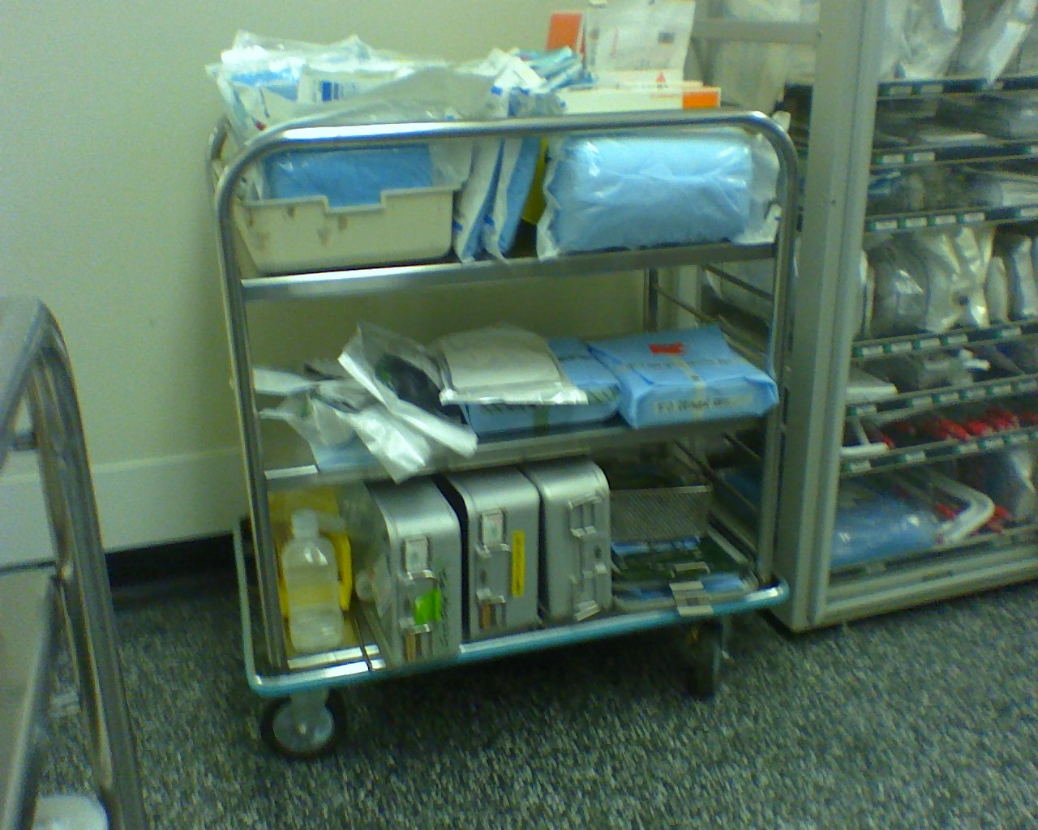
Figure IV-6. SFG case carts

- Communications is a challenge, particularly regarding white board changes, charge nurse, status of cases and location of staff. There seemed to be no clear pattern of how communications should occur, particularly regarding white board changes, status of cases, movement of patients and certain tasks.
- Paperwork from inpatient floors was not always correct or was incomplete causing delays in room turnover because the patient’s paperwork was not fully ready when needed.
- Internal Schedule; times shown on the daily printed schedule could be confusing to some. The definitions seemed unclear. For example, is start time for each case on the printed daily schedule the "wheels-in" or "cut-time"?
- Schedule results, how actual times compare to the scheduled case times was not as high as it could have been if past averages were consistently used. Over ½ of cases differed from scheduled time by more than 30 minutes. See Figure IV-8.
- Housekeeping staff was not always available in sufficient numbers when needed. There seemed to be no increase in staffing at busy times nor were daily breaks for housekeeping staff in line with the flow within Surgery
- Clocks, not all are in agreement. We observed differences up to 10 minutes. To the extent time data is recorded using times on computer terminals – this does not matter. However, when filling our paper records, inconsistent times might be recorded.

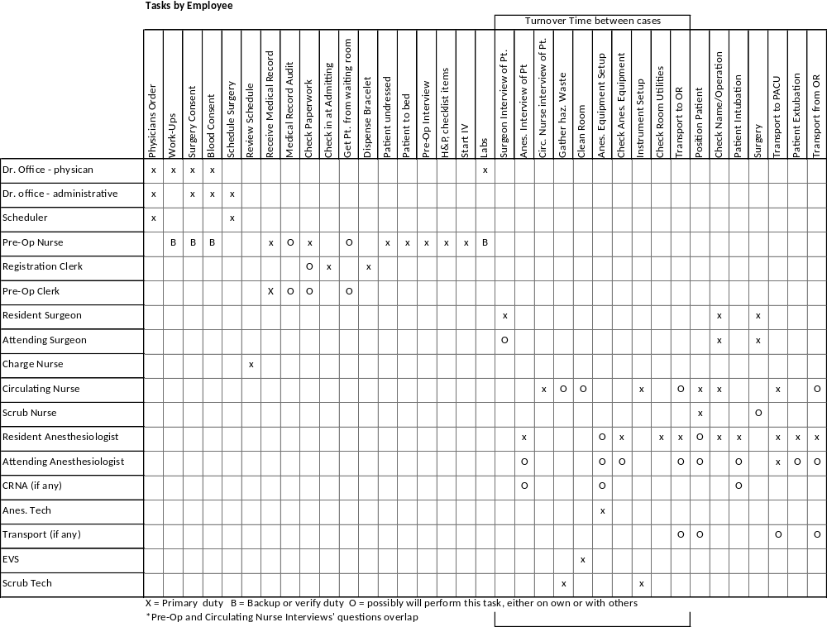
Figure IV-6 Surgery activities

Based on these observations and problems, we recommend the following changes:

- Regarding the overall pace of room turnover, several things can be done to improve it.
  - Develop, implement & widely circulate a report card or dashboard with room turnover time (TOT), utilization, scheduling performance and start time information. An example with recent SFG data is shown in Figure IV-7. A publicized regularly produced dashboard that highlights performance by teams and individuals as well as overall surgery is needed. (See later section on data & reports) Once individuals know that results are being measured and they can see how their performance compares to similar institutions, there will be a greater incentive to improve. Some hospitals we have worked with have found that reporting individual performance, such as by doctor, “shakes things up” and creates discussion regarding bottlenecks and other reasons for poor performance. This leads to a willingness to identify problems and to work on their solution. Visibility helps.
  - Increase role and authority of Charge Nurse. The individuals who serve as charge nurse seemed to be very capable and are strongly involved in assigning staff to rooms and maintained a close watch on activities. However, it should be explicit that their responsibility includes performance in terms of room utilization and turnover time.
  - The presence of individual staff is critical to starting cases promptly and minimizing turnover time. First case starts, seem to be particularly impacted by the availability of attending physicians. Their presence in the OR at the scheduled start time should be monitored, counted and penalties, if necessary, enforced.
  - Ideally performance results should be tied to incentives. These could be recognition or various rewards.
- Regarding the organization of patient flow, several changes can assist throughput and the resulting patient access:
  - Set up a "pull" responsibility from the operating room to promptly move patients in. By “pull” we mean that the staff, probably the circulating nurse for the incoming case, should be responsible for not only getting the room ready but working to assure the incoming patient is ready and for moving the patient into the room as soon as possible. This should be begun before the current case is done. A “push” system would be one whereby some external supervisor pushes movement. The use of a pull philosophy puts responsibility into the hands of the person who can best take action and minimizes delays if done properly.
  - Improvements could be realized immediately by making the same set of patient flow expectations clear to everyone. It will be more effective if it can be tied to a regular report (dashboard) and an incentive system.
  - Review the above detailed process list and have clinical management determine which redundant steps should be eliminated. Perhaps a few discussion or focus group meetings are needed to execute this.
  - Implement surgery clinic. All patients should go to such a clinic shortly before to their day of surgery to assure preparations are complete and the patient is fully informed.
  - Implement comprehensive pre op checklist. By creating clear expectations for each team (pre-op, anesthesia, etc.) they can begin to trust that the other team has done their part instead of needing to double-check everything.
  - Use one or two rooms alongside holding corridor for pre op holding. This would increase daily throughput.
  - Increase holding area space. Add block room in nearby room or as part of general rearrangement is needed and would increase daily surgery capacity. If the number of average monthly cases requiring a block were determined, the benefit in the increased number of cases could be computed. For example, if there were 2 cases a day and the block room saved 45 minutes of operating room time for each cases, the benefit would be an added capacity of $1,500,000 ( 2 cases x 45 minutes x 22 days per month x 12 months x $64 per minute) less any additional costs for the block room.
  - Find office space nearby to be converted into a larger waiting area for both patients and families. The ratio of waiting space to number of rooms is much less than normal and, while it would not necessarily improve throughput, it certainly is needed for a minimal level of comfort.
- Communications are also important factors regarding throughput.
  - Review policies with the various surgery services regarding how residents are instructed and what is the division of responsibilities concerning room turnover and patient preparation. Perhaps publish a set of standards for all services regarding resident responsibilities and responsibilities of attending surgeons regarding instructions for patient preparation and defining equipment requirements. Perhaps require the attending to be in room earlier and specify added responsibility for Service Nurse regarding maintaining equipment preferences as well as contacting the Attending a day in advance regarding plans for each surgery. Perhaps more education is needed for residents and attendings regarding what is to be done prior to a case. There should be a checklist regarding Operating Room positioning so that there is no slowdown in starting each case.
  - Regarding SPD, training, assign responsibilities, review procedures, communications and keep a SDP person in sterile core area. Make use of “missing item” board. Culture change seems necessary. Perhaps a person from SPD should remain in the sterile core to make sure necessary material is ready and to provide feedback to the basement group to prevent future problems. Would focus group help?
  - Walkie-talkies and electronic white boards are helpful. The white board or perhaps a separate board could log who has completed the preparation work for each case
  - Increase role of Charge Nurse. As noted earlier, the CN should monitor trends in metrics such as turnover time and should post the results in a visible area near the whiteboard where staff often congregates.
  - Pre op checklist (one was designed at SFG in 2000, and a different type of checklist that was recently suggested for certain ortho cases)
  - Show TOT on schedule, don’t show back-to-back. Change wording on schedule heading so that its clear when a case is to start and to end.
  - Review delay codes and reporting results, are results accurate and effective in making improvements?
- Compare housekeeping staffing to surgery schedule considering both on/off times and busy/slow times. Could housekeeping be responsible to the charge nurse, so that they would not be allowed to take break during a busy time?
- Digital clocks would be more easily synchronized. The display could be analog. Several such products are available.

Our recommendations were reviewed in several meetings with surgery management. We remain available for review of these findings and recommendations.

Data & Results

At the start of the project there was no overall regular patient flow report. We therefore developed a suggested report following a format that we have used in prior projects. The values are based on raw data provided us from SFG from their computer system. This system includes patient movement times recorded by nurses in the operating rooms. With this raw data it was possible to compute various descriptive metrics about patient flow in surgery. For example, its possible to determine:
- Room turnover time (wheels in to wheels out)
- Room utilization
- Turnover time between surgeries (close to cut)
- Fraction of first cases starting on time
- Schedule accuracy, how actual times vary from scheduled times
- Distribution of these measures by time of day, day of week, room, service, surgeon, nurse or anesthesiologist

After computing these values, certain results indicated a problem. We were told, in advance, by hospital management that room turnover time was to be our priority because they felt is was a problem. The data bore that out. Often hospitals turn surgery rooms over in an average of ½ hour and often considerably less. An average of 20 minutes is not uncommon. This metric varies by type of surgery; some are more complex in terms of moving one patient out and moving another in. Also, a teaching hospital may have longer turnover times but this need not be a large difference since the students, such as the residents, are not responsible for many of the events that occur during turnover. By having the additional staff of resident surgeons and anesthesiologists, the turnover tasks have sufficient manpower to do the job.

The room turnover time, the time from when one patient wheels out until the next wheels in, is nearly a full hour. During the three months for which we received data, the overall average was higher in the afternoon than in the morning and was higher at the beginning and at the end of the week.

An important metric is room utilization. This represents the percent of the day during which the operating rooms are in use. We computed utilization as the time patients are in a room plus an allowance for room turnover – since a patient cannot be moved in the instant one patient leaves. From an economic standpoint, utilization is important since the OR is a very valuable resource. The hospital said they calculated a $64 per minute value.

Room utilization can be calculated two ways; as the usage of all rooms in the hospital and the usage of rooms staffed by nursing. Sometimes, a physical room exists but nursing staff has not been brought in to operate it. In either case we calculated utilization only during the regular weekday daytime shift.

Room utilization was an average of 54 percent and staffed room averaged a utilization of 79 percent. Typically hospitals target about 85% since 100% is considered unrealistic.

Schedule accuracy is another metric of interest. In order to make full usage of OR capacity, its necessary for the first case of the day to start on time as scheduled and for the remainder of the schedule to reflect a reasonably accurate plan. If not, the opportunity to complete the maximum number of cases is lost. This calculation is difficult; we did it for only one month, because the schedule history and the patient movement history are not stored in a common system. Past schedules were available only in paper form. However, it is feasible to set up a common digital file or do such calculations only periodically as a sample. See Figure IV-8.

We found first case starts to be relatively good. For the days we had data, about 90% of the cases started on time.

We have found, and many hospitals have also concluded, that a regular patient flow “dashboard” or report card is helpful to improving and maintaining good patient flow. The report needs to be clear and easy to interpret. It should measure important variables, such as we have described above. Most of the commercial surgery information systems provide such a dashboard with room utilization, turnover time and scheduling metrics in terms of their details, trends and comparison to benchmarks. SFG, as noted in our recommendations, should do this. While patient flow data is currently cumbersome to utilize, the raw data is there. The computer system used by nurses in the operating room records the important patient flow times and is the basis for such a report.

We also believe such a report should receive wide circulation among the staff. Employees want to be proud and satisfied with their work but need to know how they are doing. Even performance data on individual physicians, while it may “stir things up”, provides a feedback to the doctors. It focuses attention on throughput and provides motivation. Some hospitals we have worked with have reported individual physician performance but with names hidden with a code whereby the physician knows their own ID code but not the code for others.

Figure IV-7 Surgery Dashboard

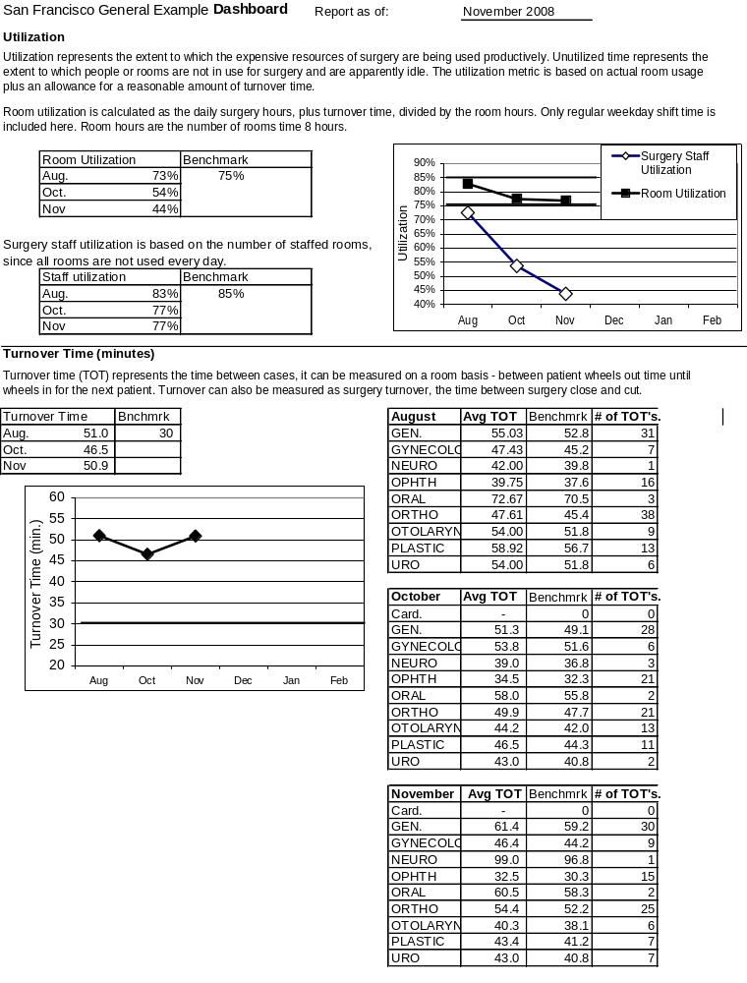
Figure IV-7 Surgery Dashboard (continued)
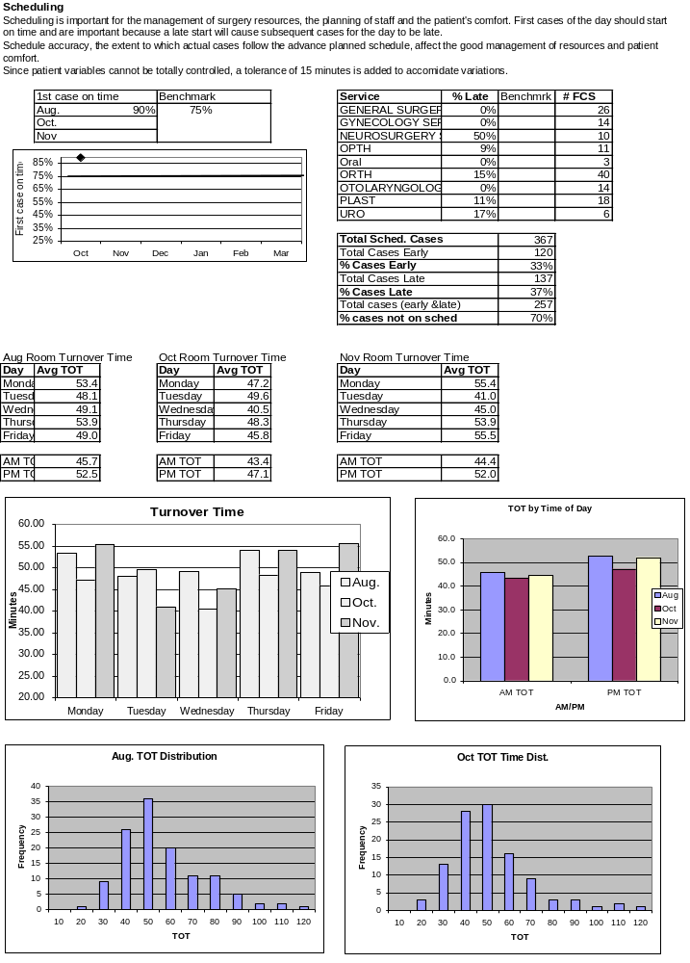

Figure IV-7 Surgery Dashboard (continued)
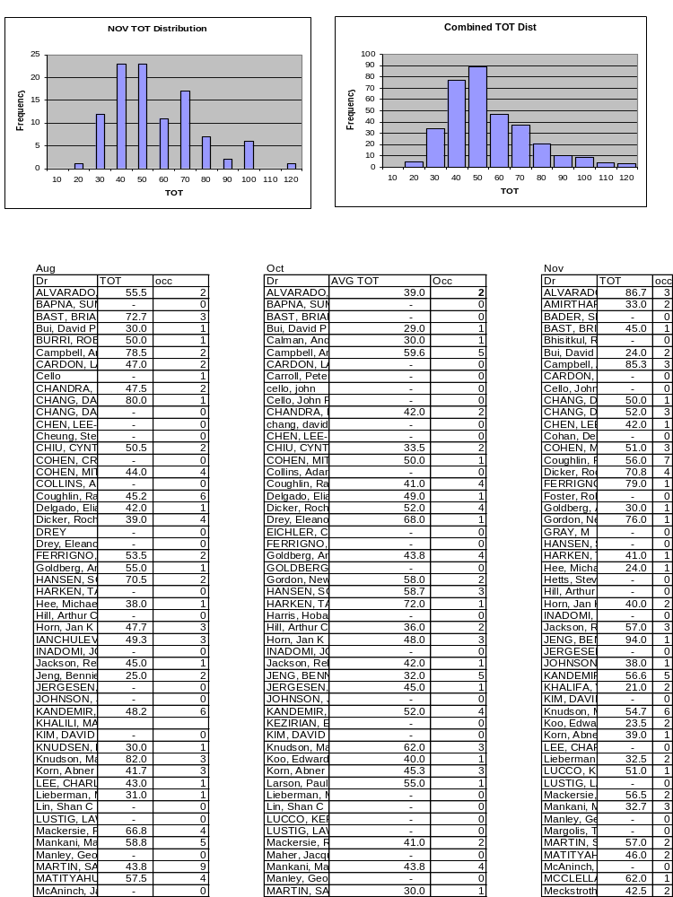

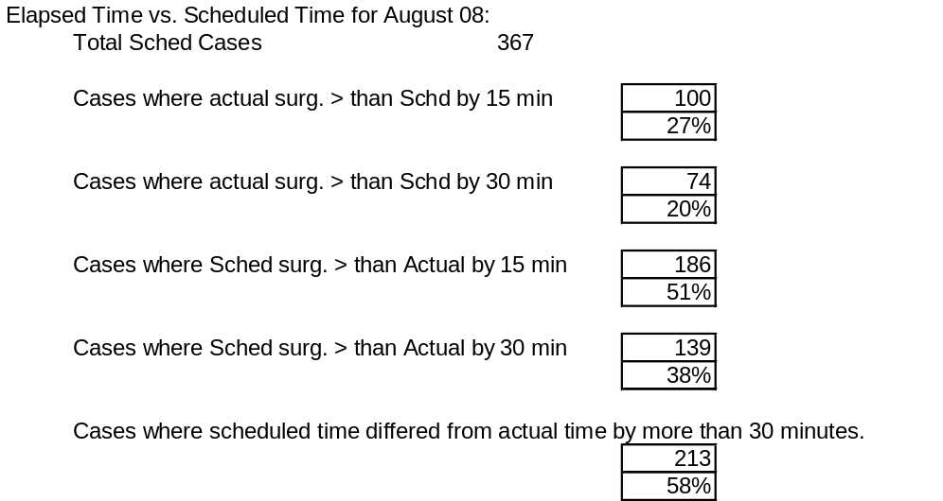
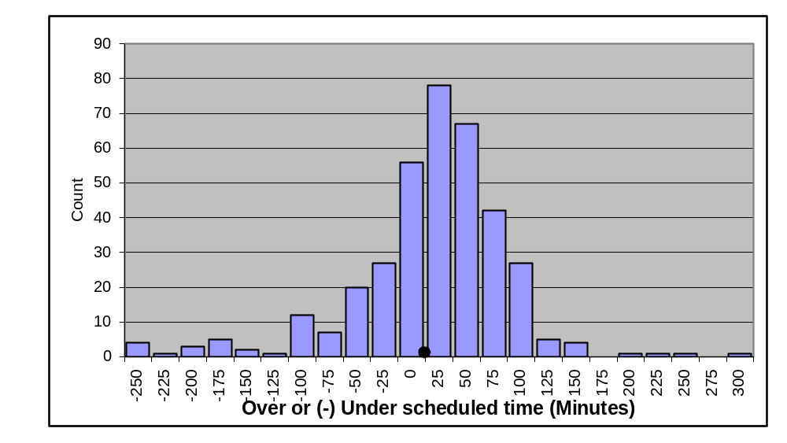
Figure IV-8 Scheduling Accuracy
(Data only for August 08)

Appendix

Proposal Evaluation Matrix

A matrix of a weighted average of scores for various attributes was used to evaluate the proposals received from hospitals. The total for each hospital was the sum of each hospital’s score on an attribute times the weight for that attribute. The top 3 total scores were used to select the hospitals.

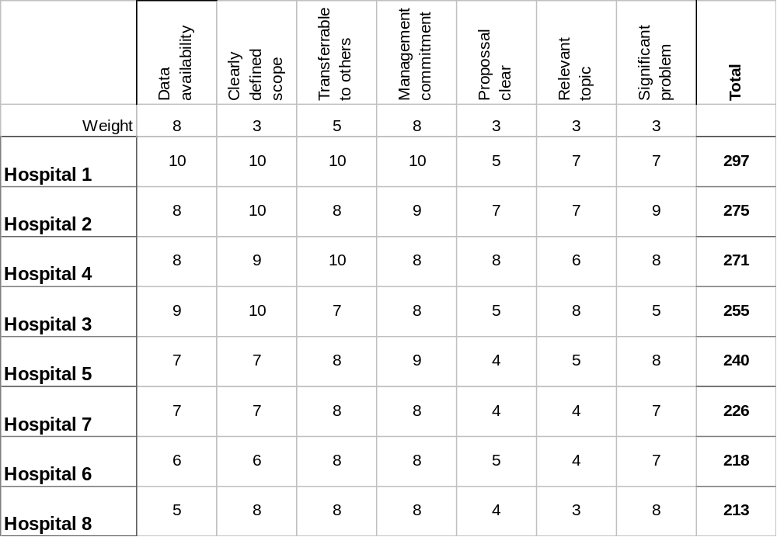

Project Startup Checklist

The following was used at the start of each project.

Checklist for ___________________ completed on_________

Discuss and complete the following with hospital at the start. Enter notes.

- Scope, it is ______________________
- Agreement letter signed ___________

Logistics
- Primary contact person is ________________
- Schedule Kick off meeting with as many people as possible ___________
- CEO meet ______________
- Parking _______________________________
- HIPPA requirements, TB requirements __________________
- Access badges __________________________
- Office space, computer access _____________________________
- Will do follow up memo __________________________

Content
- Who are the key stakeholders in this? _________________
- Metrics, are we clear? What is available now? ___________________

- We do ongoing status reports & meetings __________________
- Explain early tasks; process maps, data sources
- Any phonebook or directory available?
- Any prior studies, consultants, prior work _____________________
- What documentation is available on processes, forms control?
- Who is IT contact, source of queries? _________________
- What are their regular meetings, committees _________________

Hospital Data

The hospitals in this project all maintained detailed digital records regarding patient flow. Timing of patient movement was recorded by nurses and by anesthesiologists, often in separate systems. An example of the raw data used as an input for the analysis this report is shown below. The hospitals also recorded patient movement in admissions, pre op and recovery, although often in separate computer systems or more limited paper records.

Example data:
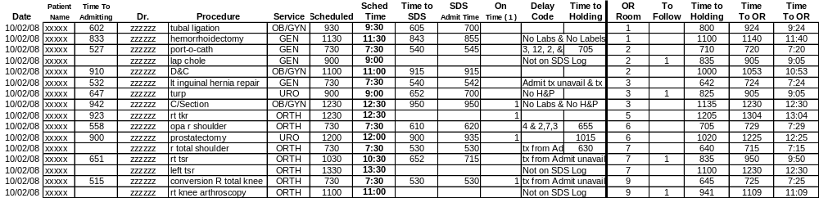

Based on $64 per minute, 8 rooms, 2 turns per day, 260 workdays per year and a 10 minutes savings per turn. This equals $2,662,400 per year.

